Mrs. Travis Flipped Classroom
What is a “flipped class”?
“Flipped Class” is a method of teaching and learning that turns things around and puts kids in control of their learning. Students watch videos of lecture material at home instead of listening to a lecture in class. Students take notes and answer questions while they watch the video at home. 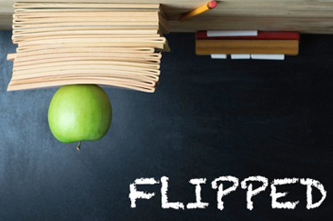
When students come to class, they use the information that they learned in the video to do things that require people to be together, face to face. This includes doing labs and activities that put the lecture material to use, creating projects and presentations based on the information that they viewed in the video. Students can ask questions of the teacher and their peers/other students in class to clarify questions that they have about the video lectures.
The teacher can work with groups of students and gauge their understanding and help those who need it.

What if I forget to watch?
This is the same as forgetting to do traditional homework. If you forget to watch the video, you won’t be prepared for class and will not be able to participate in the class activity or lab. In most cases, you will be sent out of class with another teacher to watch the video and take the notes that are due that day. You will also be responsible for catching up on the work that you missed in class.

What if Students don’t have access?
Don’t worry!!! Students who do not have access to the internet at home can do several things:
- Watch the video before or after school or during Eagle Time.
- Watch the video on a flash drive/memory stick or save to your computer. Gather any questions that are required with the video and have Mrs. Travis download the video for you.

What do Students Need?
Students need access to the internet to view the videos. This can be done on their computer, tablet, Nook, Kindle, iPad or smart phone. Students need to take notes on the video and answer and corresponding questions with the videos. It would be a good idea to keep all notes in a notebook.
Class Supplies

- Notebook
- Notecards
- Highlighters
- 1 GB flash drive/memory stick
- Ear buds/ear phones

Advantages of Flipping
I see many advantages to flipping the classroom as I spent most of the end of last year and the summer doing research and discussing with many teachers about this technique. First, students are able to watch and learn at their own pace. If the material is familiar to them, students can watch the video, take notes and be finished. If the material is challenging, students can stop the video, back up to view sections again and can make notes at their own pace. You just can’t do this in a traditional 30+ student classroom.
Students can re-watch the videos before a test or the EOC to review at their own pace.
Students have time to apply their knowledge in class for experiment, activities and projects making class time more meaningful.

What will we do with class time?
A frequent challenge is how to fit everything in to our crowded class schedule. Teachers struggle with presenting the American History curriculum thoroughly and including the experiments, activities and projects that make history relevant.
Flipping class allows teachers more flexibility to add relevant experiences. It allows students the time to apply the facts that they learn during lectures, from vocabulary or textbooks.
For example, the students learn about immigration to the United States during the 19th century. The flip videos present the basic information and vocabulary from this time. In class, students participate in an active debate by becoming either a Party Boss, immigrant, Nativist, or Progressive. Each group explains their opinion and the class conducts a civilized argument.

Resources:
www.mrstravishistory.weebly.com

